**WWS 37 - PROJECT INSPECTION**

**DATE: 24th february 2022**

Team: T6 (ProJavaDevelopers) Leader: Leonel Mantuano

Team: Project: T8:(RocketTeam) Leader: Alan Shuguli

sin nombre de proyecto

36 SHUGULI REINOSO ALAN JESITH

37 SIMBAÑA SIMBAÑA JONATHAN GUSTAVO

38 TAPIA ALBAN ANDREA JULIANNA

39 TAYO RUIZ SEBASTIAN ALEJANDRO

40 TECA TELLO CAMILA MILENA

Modularity 9/10

Clean code 9/10

MVC 8/10

One design pattern 10/10

Diagrams consistency 8/10

Unit tests 2/10

GUI navigability 9/10

GUI fields validation 9/10

Functionality 10/10

MongoDB 10/10

______________________________

TOTAL             84 /100

Video:  <https://youtu.be/OfIyTMYa23U>

Modularity

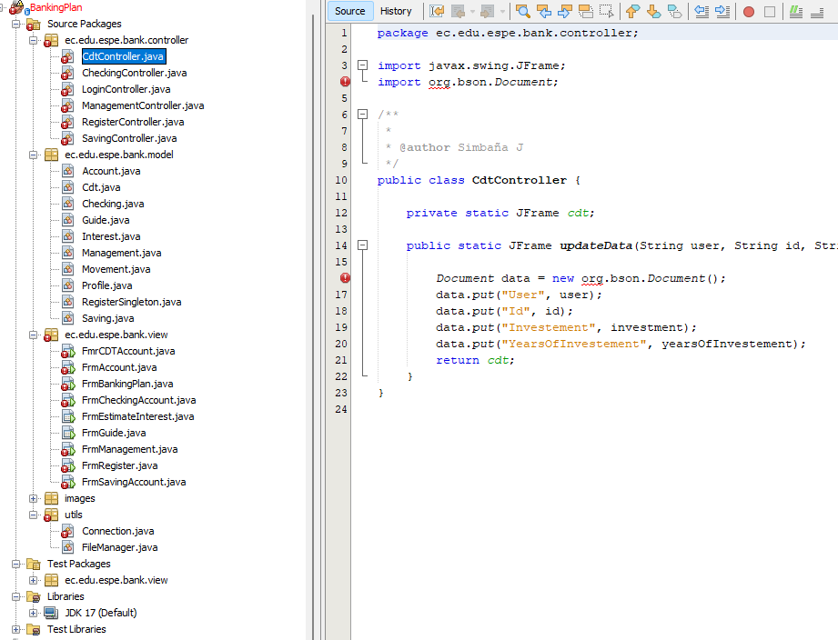

Clean code

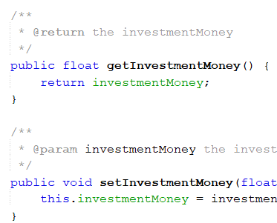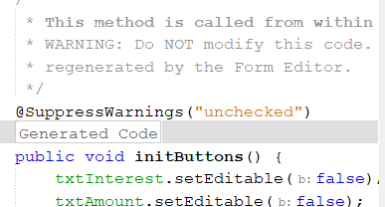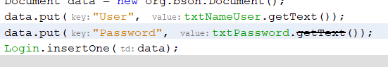

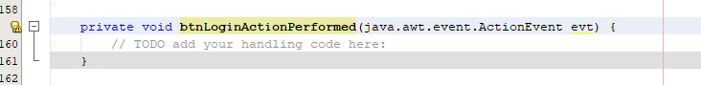

button does not call function

**MVC**

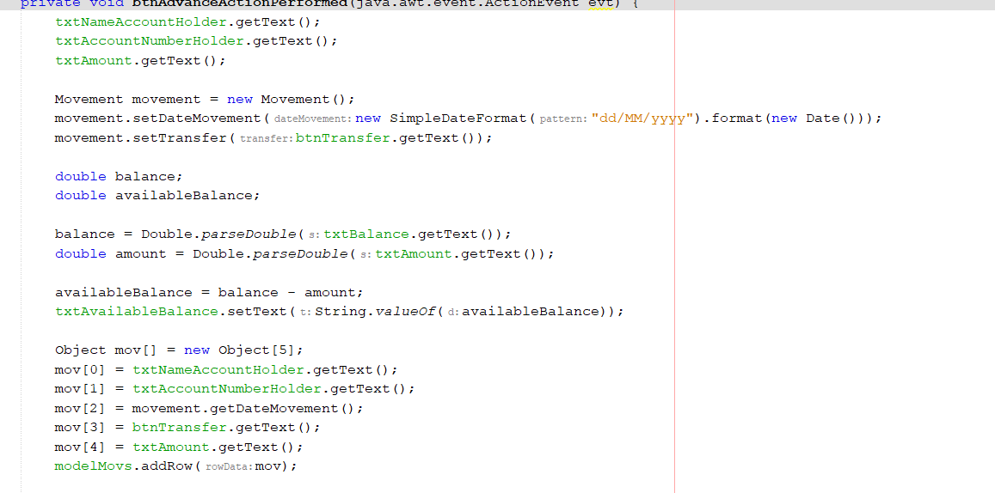

* Code in the btn

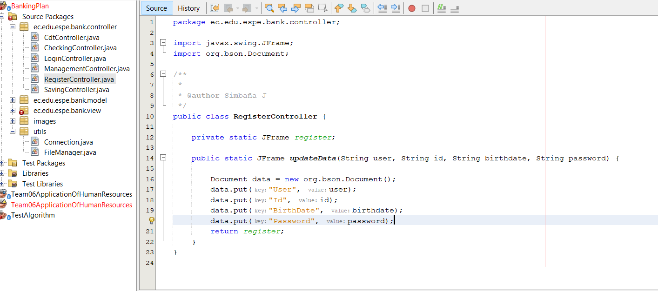

**One design pattern**

* Singleton

**Diagrams consistency**

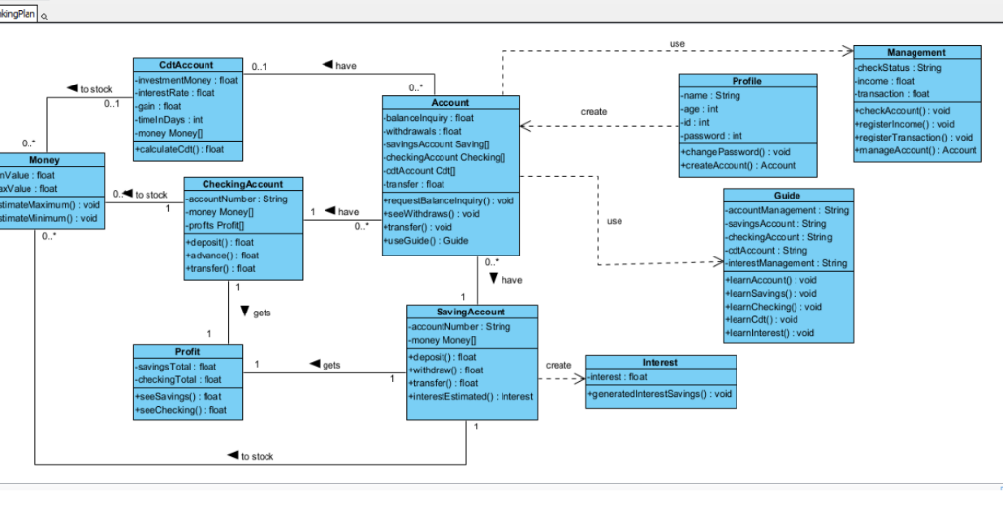

* Missing packages

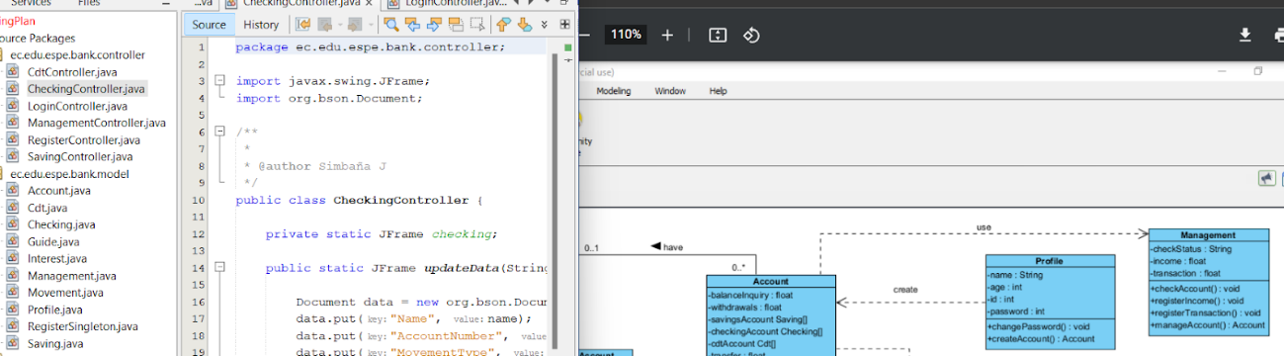

* Lack of classes and connections

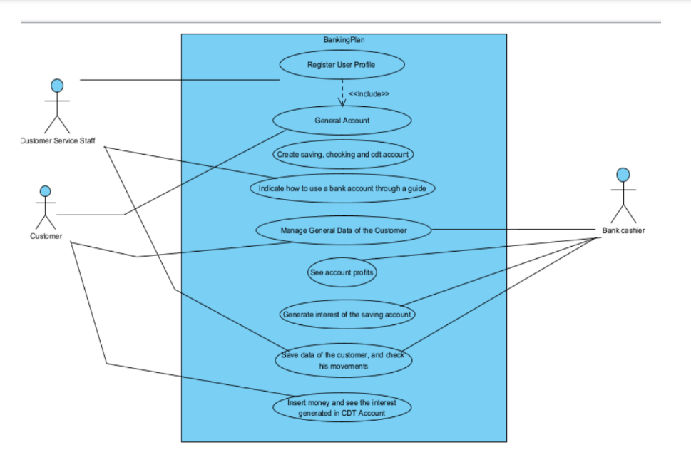

**Unit tests**

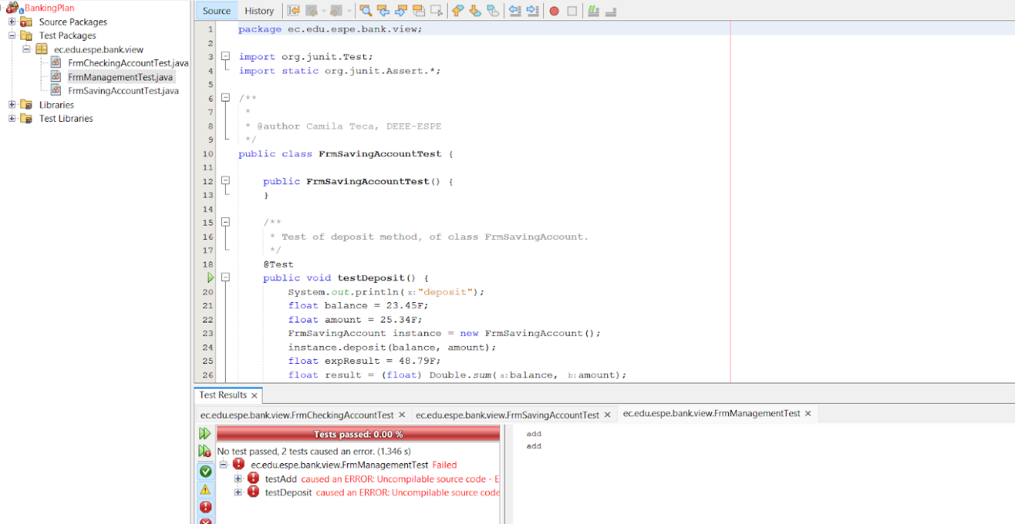

**GUI navigability**

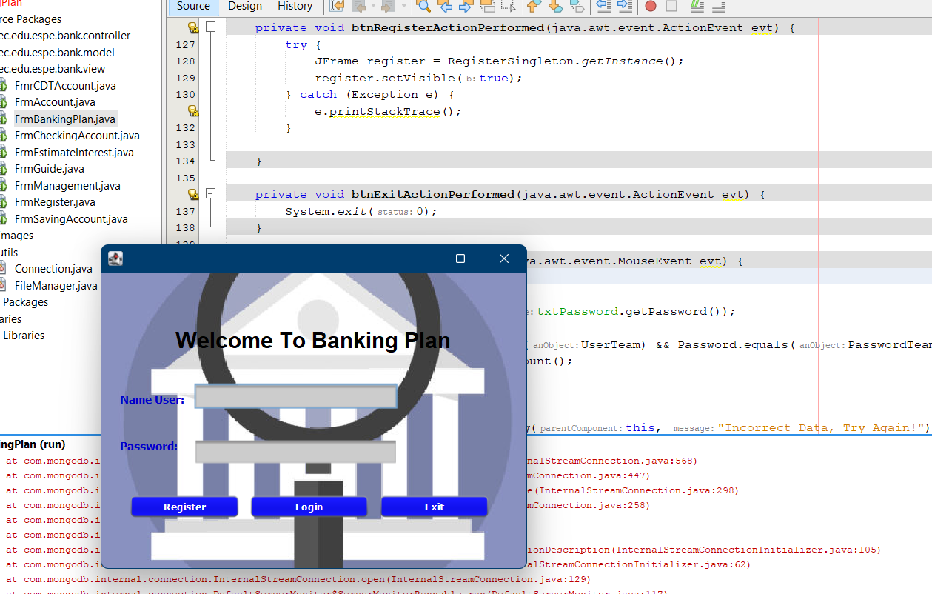

**GUI fields validation**

**Functionality**

**MongoDB**

